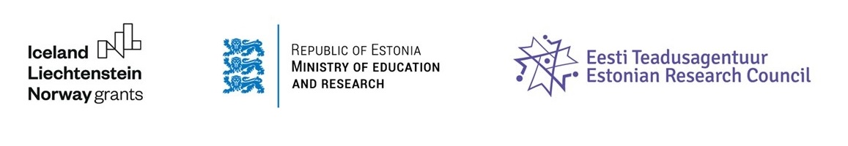

Baltic Research Programme funded under the EEA Grants (2014-2021)

Results of the Estonian call 2018/2019

By the deadline of 31 January 2019, 130 proposals were submitted.

Table 1. Number of proposals and amount of project grant applied by Project Promoter

Institution (Project Promoter) | Proposals | Applied funding
University of Tartu | 60 | 52 943 266,40
TalTech | 42 | 36 372 045,79
Estonian University of Life Sciences | 8 | 6 999 910,31
Tallinn University | 8 | 7 663 867,07
National Institute of Chemical Physics and Biophysics | 3 | 2 927 500,00
National Institute for Health Development | 3 | 2 367 240,83
Competence Center of Food and Fermentation Technologies | 1 | 999 235,00
Cybernetica AS | 1 | 997 461,25
Estonian Literary Museum | 1 | 979 152,74
Estonian Academy of Arts | 1 | 794 500,00
Estonian Business School | 1 | 697 862,35
Tartu University Hospital | 1 | 800 000,00
Total | 130 | 114 542 041,74

Out of the 130 applications, 46% were submitted by the University of Tartu, 32% by the TalTech, 6% by the Estonian University of Life Sciences and the Tallinn University, and the rest of 10% by the other research institutions.
The smallest applied amount of grant was 399,375 EUR, the biggest 1,127,500 EUR and the average was 881,093 EUR. Total amount of applied funding was 114,542,041 EUR. Available total budget for this call is 6 MEUR.

Table 2. Number of proposals based on duration of project

Duration of project | Proposals
2 years | 1
3 years | 48
3 years 1 month - 3 years 4 months | 8
3 years 6 months - 3 years 11 months | 13
4 years | 60
Total | 130

Less than half of the applicants have applied for funding for about 3 years, and more than half of applicants applied for about 4 years.

Gender balance

Out of the 130 Principal Investigators, 84 were males (65%) and 46 females (35%). Gender balance within the senior research team of Project Promoter: 270 (56%) males and 216 (44%) females. Considering the participation of senior research staff, the minimum involvement was 1 researcher and the maximum one 12 researchers. On average, 3 researchers participated in a project as senior research staff.

Figure 1. Number of male and female Principal Investigators (Project Promoter)

Figure 2. Gender balance in the senior research staff of Project Promoter

Areas and challenges of the call

Proposals were invited in all areas of fundamental and applied sciences. In 55 applications (42%), more than one Frascati research area was listed, in which case the proposal is placed in the area with the highest proportion. The 12 applications were those identified by the applicant as 50% for one and 50% for the other, for which the application is placed in the figure that was first mentioned in the application. Applications were only distributed between domains for statistical purposes, evaluation based on this distribution is not performed, the content of the application is taken into account in the assessment and applications are evaluated in a single rank.

Figure 3. Division of proposals based on Frascati research fields

Challenges

All the proposals were submitted as challenge-based, except one which was marked as not addressing any of the challenges. Average number of challenges submitted by the project promoters was 2. There are 58 proposals addressing 1 challenge and 1 proposal addressing 5 challenges.
The most submitted challenges are the challenge 6 (more effective use of resources), challenge 4 (environmentally friendly solutions) and challenge 1 (public health; translational medicine; health technologies).

Table 3. Number of proposals addressing the respective challenge

Challenge 1 (Public health; translational medicine; health technologies) | 55 proposals
Challenge 2 (Migration; social inclusion) | 20 proposals
Challenge 3 (Regional cyber security; public security) | 11 proposals
Challenge 4 (Environmentally friendly solutions) | 56 proposals
Challenge 5 (Regional economic development; employment; labour market regulations and social policy) | 34 proposals
Challenge 6 (More effective use of resources) | 58 proposals
Application does not address any of the challenges | 1 proposal
Table 4. Number of proposals based on a number of submitted challenges

58 proposals | 1 challenge
48 proposals | 2 challenges
16 proposals | 3 challenges
7 proposals | 4 challenges
1 proposal | 5 challenges

Project Partners

It was mandatory to involve at least one partner from another Baltic State and at least one partner from Norway, Iceland or Liechtenstein. The most involved Project Partner’s country was Norway (147 proposals) followed by Lithuania (109) and Latvia (109). 27 proposals had involved partners from the third countries. On average, 3 project partners were involved per 1 project. In total, 263 partner institutions were involved, and 420 names of partners were given.

Table 5. Number of proposals having the Project Partners from the following countries

Project Partner’s country | Number of proposals
Norway | 147
Lithuania | 109
Latvia | 107
Third countries | 27
Estonia | 21
Iceland | 12
Liechtenstein | 1

Table 6. Most involved partner institutions

Partner institution | Number of proposals
University of Latvia | 22
Norwegian University of Science and Technology | 14
Vilnius University | 14
Kaunas University of Technology | 10
Riga Technical University | 10
University of Bergen | 8
Lithuanian University of Health Sciences | 7
University of Iceland | 7
University of Oslo | 7
Estonian University of Life Sciences | 6
University of Stavanger | 6
Vytautas Magnus University | 6

Source: Estonian Research Council (15 February 2019)

