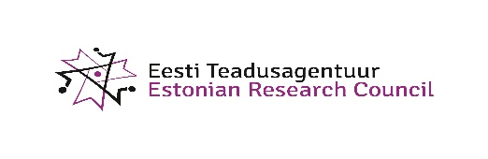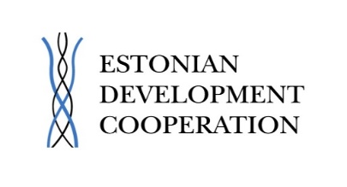

Seminar “Find your R&D partners in Ukraine. Real opportunities"

Time: November, 3 at 14.30-17.00

Venue: Estonian RTD Office, Square de Meeûs 1, First floor

Registration is open at: http://www.etag.ee/uritus/seminar-find-partner-ukraine-not/

Agenda

14.00-14.30
Registration

14.30-14.40
Welcome
Kadri Sirg, Head of the Estonian RTD Office

14.40-15.00
How can Estonia contribute to Ukrainian participation in H2020?
Argo Soon, ETAg

15.00-15.30
H2020 and Ukraine
Gorazd Weiss, ZSI, Coordinator of the RI-Links2UA

15.30-16.00
Ukrainean RTD Landscape
Valentyna Andruchenko, State Fund For Fundamental Research

16.00-16.30
Ukraine association to Horizon 2020. Current activities
Stella Shapoval, Ministry of Education and Science of Ukraine

16.30-17.00
Open Fora

Stella Shapoval, Head of Division for International Scientific and Technical Cooperation, Ministry of Education and Science

Oleg Khymenko, Deputy Head of Department of S&T development, Ministry of Education and Science

Nataliia Atamanenko, International Cooperation and European Integration Department, Ministry of Education and Science

Chayka Dar'ya, Head of the Division on transfer technology, Innovation policy Department, Ministry of Education and Science

Oleksandra Fedorko, Department of Entrepreneurship Development and Regulatory Policy, Ministry of Economic Development and Trade
Oksana Lavryk, Department of International Treaties` Expertise, Ministry of Justice
Oleksii Kosharnyi, European Integration Department, Ministry of Finance
Olena Koval, National Information Center for Ukraine-EU S&T cooperation
Valentyna Andruchenko, State Fund For Fundamental Research

17.00-19.00
Reception. Discussions.

