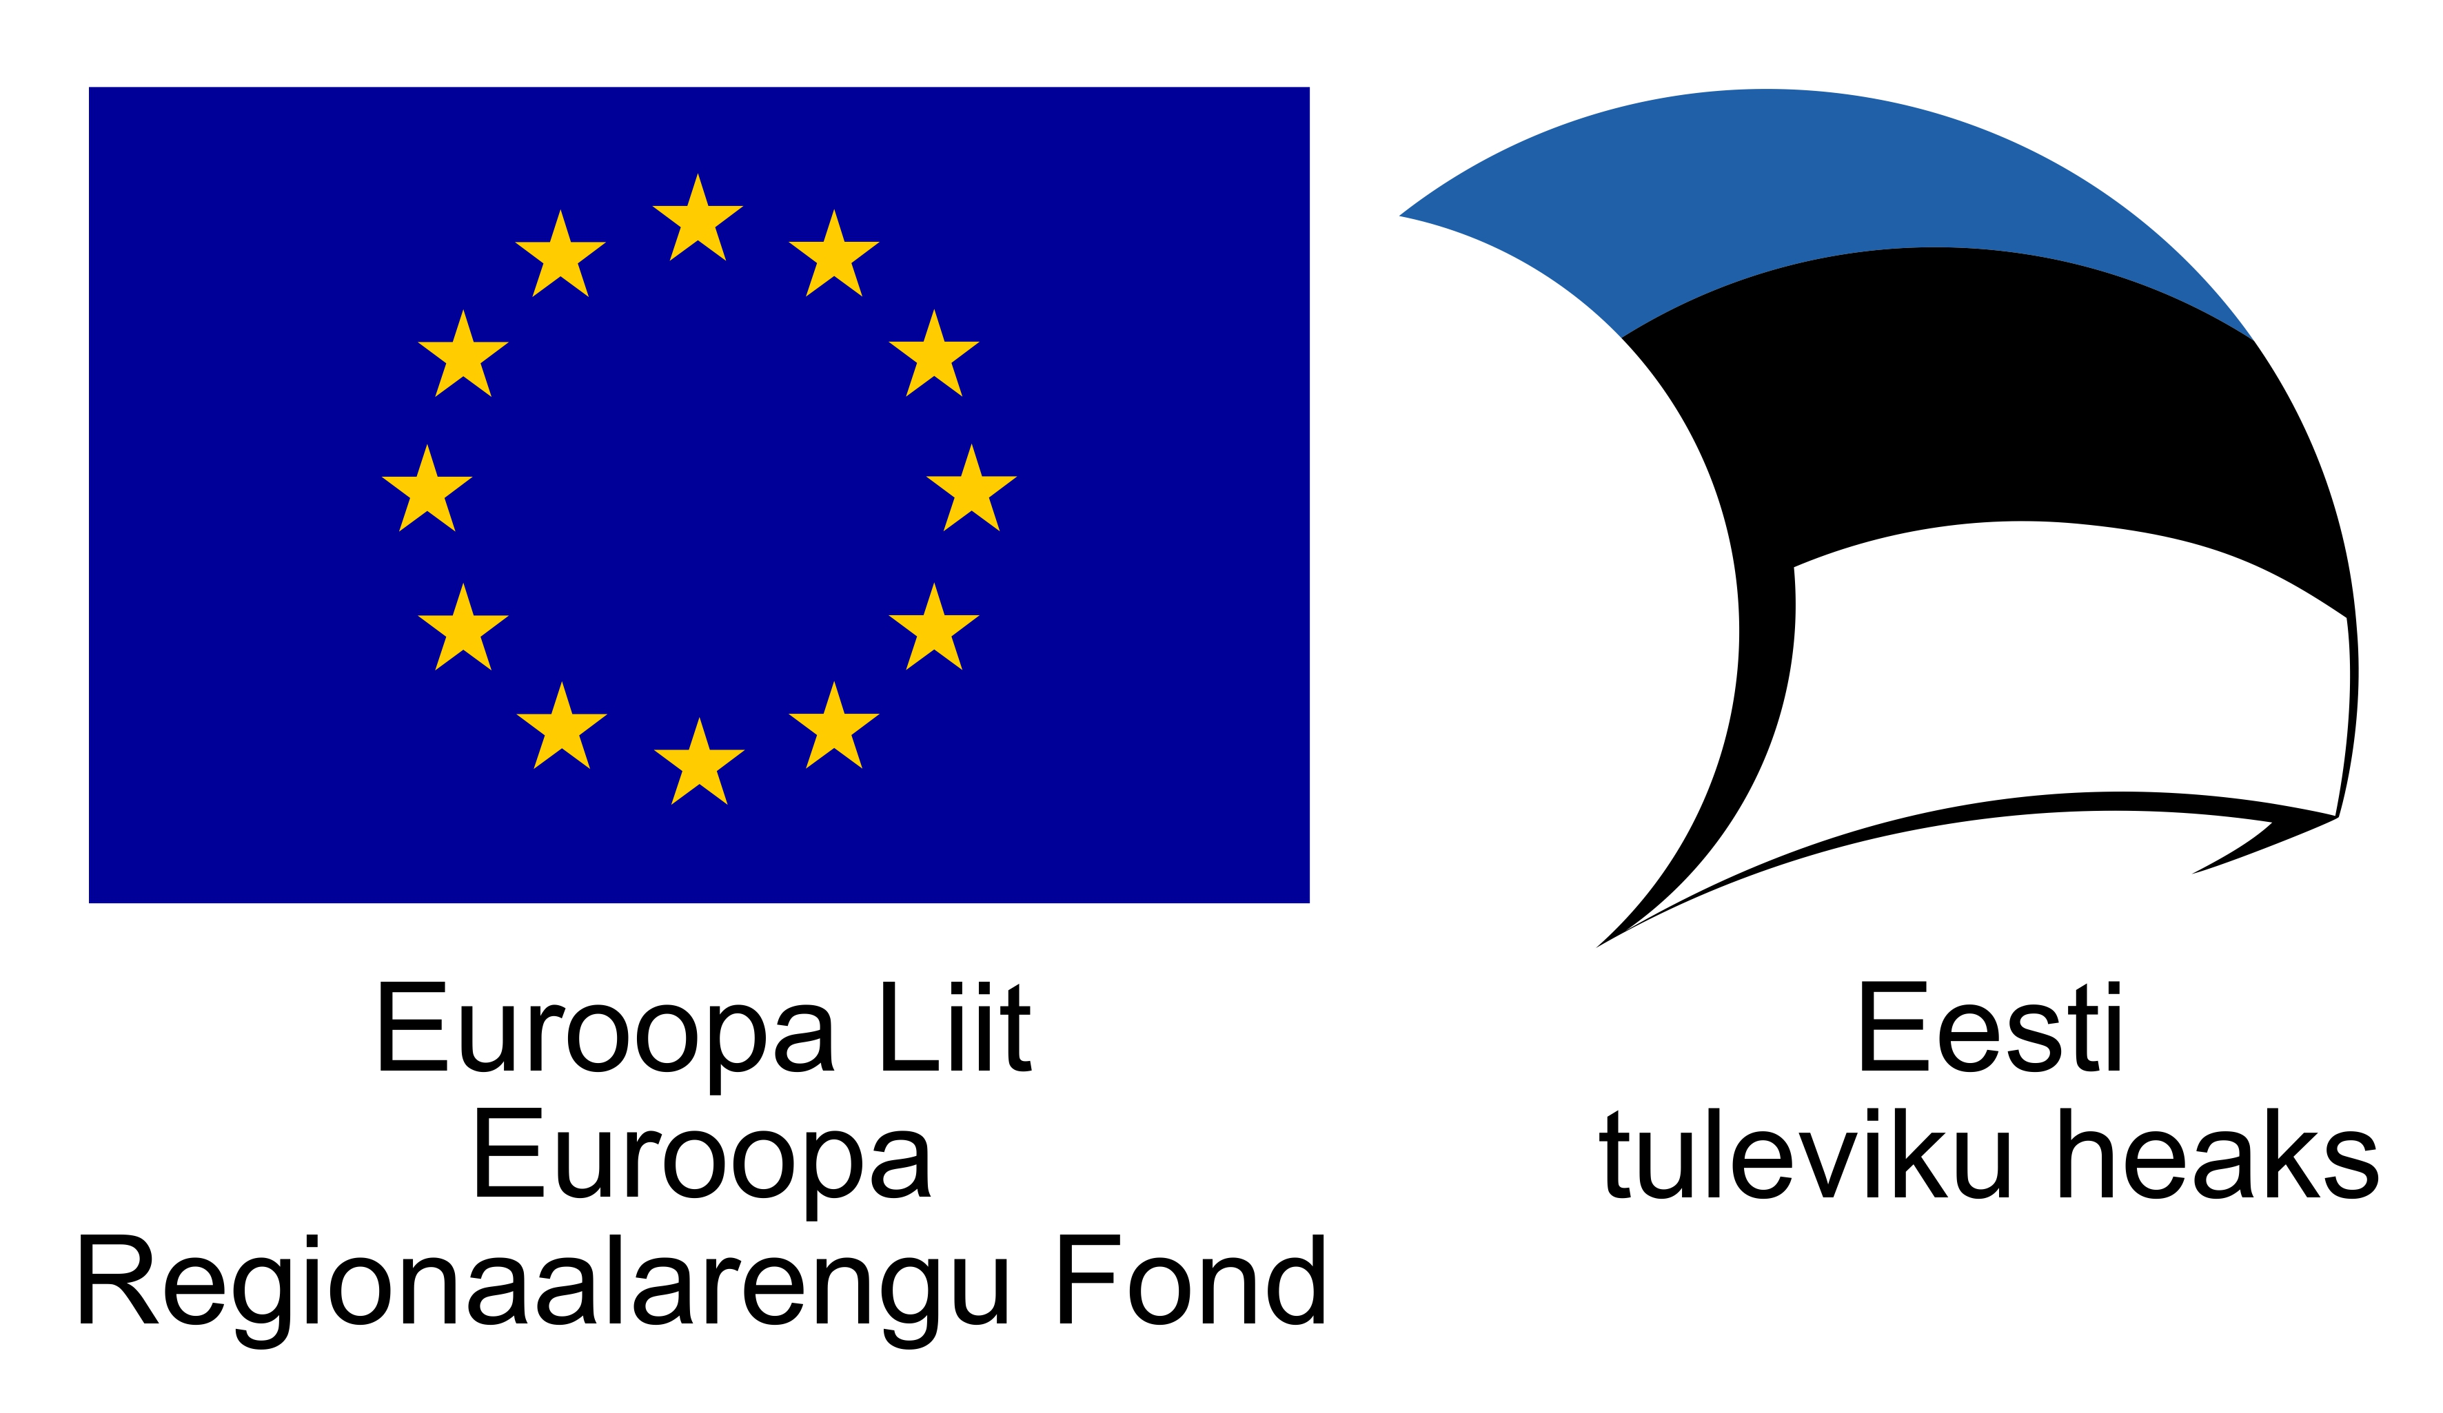

National Eligibility Criteria of research project proposal in international calls

Estonian Research Council (hereafter The Council) funds basic and applied research. Applied research is funded only as far as it is not refer to product development with commercial value and for marketing purposes.
A grant or research support is the allocation of funds by the Council for a specified purpose to carry out research work and the grant shall be awarded within an open competition.
Funding will come from the Mobilitas Pluss programme, which is partly financed by the European Regional Development Fund.
- Participants in the grant project
  - Principal Investigator is the applicant of the grant, to whom the grant has been allocated within an open competition and who shall be responsible for the use of the grant for specified purpose and for the productive realisation of the grant project. The Council shall enter into a grant agreement with the Principal Investigator.
  - The Principal Investigator
    - Must possess either the Estonian nationality or citizenship or be a permanent resident of Estonia.
    - Has an updated profile in the Estonian Research Information System (ETIS).
    - Has as a rule entered into an employment relationship with the legal person (hereinafter Institution), which is the basis of the realisation of the grant project and through which the grant shall be allocated to the Principal Investigator.
    - Must be a holder of the doctoral degree of Estonia or an equivalent academic degree (both awarded by the deadline of submission of the grant application, at the latest).
    - Must have published within the last five years prior to the proposal’s submission deadline at least three publications, which comply with the requirements of clauses 1.1 of the classification of publications of the ETIS, or at least five publications, which comply with the requirements of clauses 1.1, 1.2, 2.1 and 3.1 of the classification of publications of the ETIS; international patents are equalised with publications of clause 1.1.; the monographs are equalised to each author with three publications mentioned in clause 1.1 if the number of its authors is three or less. If the applicant has been on the parental leave or in the compulsory military service within these last five years, the deadline of the publication requirement shall be extended by the time stayed on the parental leave or compulsory military service
  - The main participant of the project is a person who participates in the substantial performance of the project. The main participant of the project shall either possess at least the master’s degree or the respective qualification and must have published at least one publication within the last three years prior to the proposal’s submission deadline, which comply with the requirements of clauses 1.1, 1.2, 2.1 or 3.1 of the classification of publications of the ETIS; or be a doctoral candidate.
- Budget
  - A budget of proposal shall consist of the research expenses and the overhead costs of the institution, through which the grant project is to be carried out.
  - The research expenses consist of personnel costs, travel costs, other direct costs and subcontracting costs. The expenses on research are clearly required to carry out the project and respectively identifiable. All eligible costs are set in the decree of Mobilitas Pluss.
  - Remuneration may be only paid out of the grant to the Principal Investigator, main participants in the project and auxiliary staff according to the time they participate in the grant project and their total salary cost for Institution. Double funding of activities already have contributions is not acceptable.
  - Travel costs cover expenses for transport, accommodation and daily allowances (except in case of internal travel).
  - Subcontracting costs cover generally only additional or complementary tasks (e.g. costs for translation, analyses, etc.) to the third parties. Core project research tasks should not be subcontracted. Subcontracting costs may not exceed 10% of the total costs.
  - Other direct costs are:
    - Consumables related to the project
    - Costs for publishing and dissemination of project results (fair distribution of costs between partner should be followed);
    - Costs for organising the meetings/seminars/conferences (only in Estonia)
    - Fees for participating in scientific forums and conferences;
    - All other costs which are clearly required for the implementation of the project and respectively identifiable.
  - Overhead costs of the institution must not exceed a maximum of 10% of eligible direct personnel costs and should cover general expenses of the institution.
  - Costs for equipment and services intended for public use (copying machine or printer publicly used, phone bills, copying service, etc. shall be covered from the overhead fee.
  - Participants’ personal expenses or expenses not directly related to the project are not eligible.
- Human research or animal tests
  - If a human research or animal tests are intended in the research project, the positive resolution of the Ethics Review Committee or Animal Testing Project Permits Committee with respect to the performance of the project addressed to the Council shall be submitted before the funding decision is made.

comprising basic monthly salary plus social security charges and other statutory costs

